
SUBJECT:
SOFTWARE C&D
3RD

LAB TASK:
MR MUHAMMAD EJAZ
SUBMITTED TO:
AFTAB GHANI
SUBMITTED BY:
DEPARTMENT:
SOFTWARE ENGINEERING
CU ID:
4329-2023

SEMESTER:
5TH
DATE:
12-05-2025

CECOS UNIVERSITY OF IT & EMERGING SCIENCE HAYATABAD, PESHAWAR

LAB 03
- Input three numbers and print the largest.
Code:
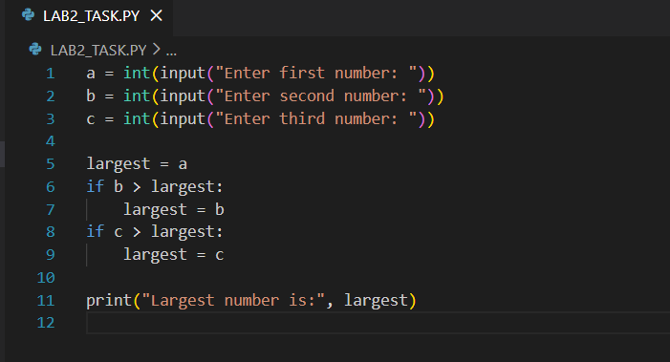
Output:
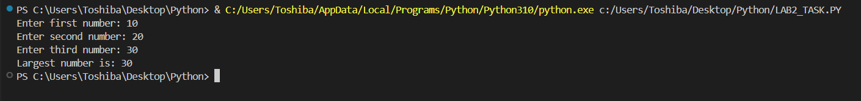

2. Write a program to calculate a discount:
➢ If total ≥ 500, discount = 20%
➢ If total ≥ 200, discount = 10%
➢ Else no discount
Code:
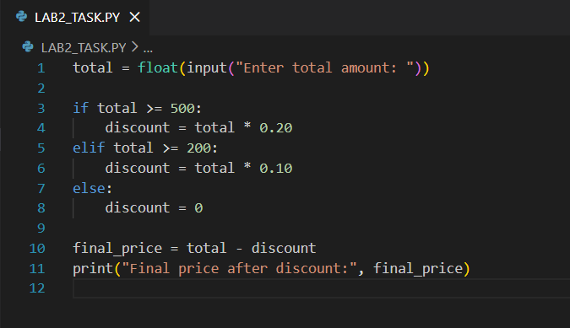
Output:

3. Write a program to Ask for a username and password; allow login only if both are correct.
Code:
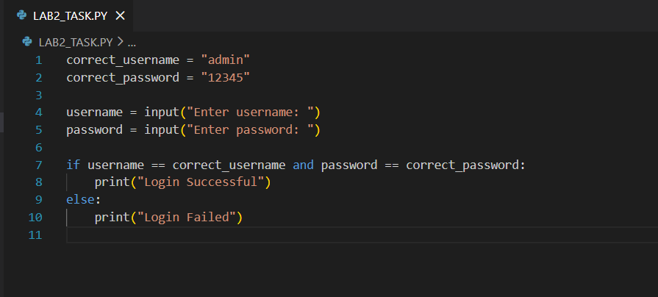
Output:
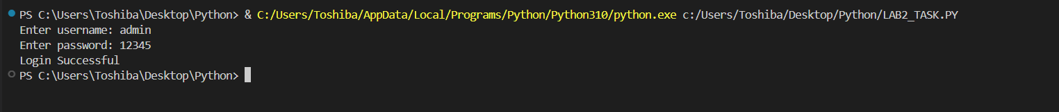

4. Write a program to Ask the user for a password;
➢ If it's short (<6), print “Weak”,
➢ If medium (<10), print “Medium”,
➢ Else, print “Strong”.
Code:
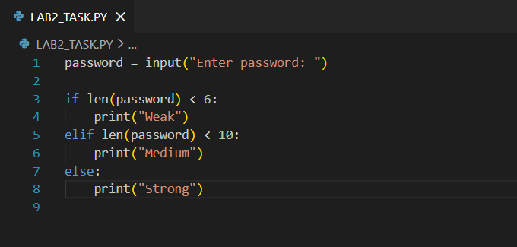
Output:
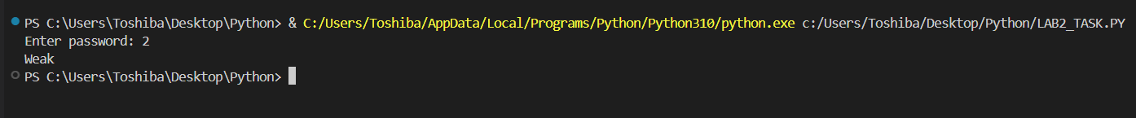

5. Write a program to Ask for speed and determine whether to print No fine, Small fine, or Heavy fine.
Code:
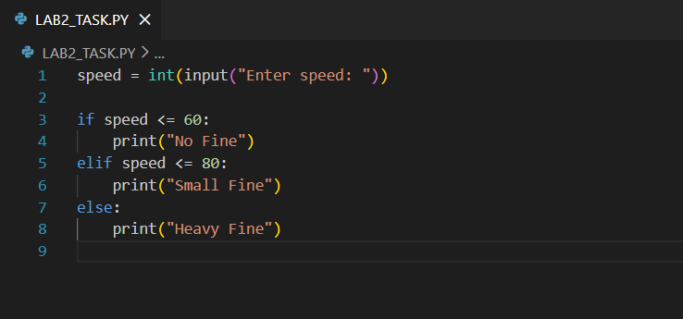
Output:
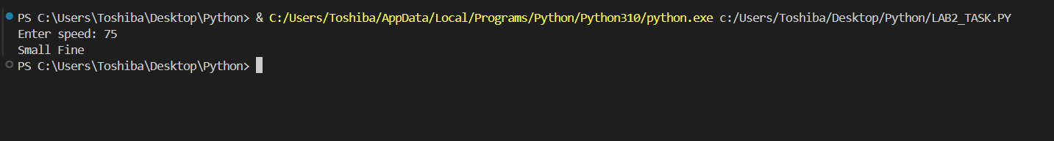

6. A shop gives discounts which is:
➢ ≥1000 → 20%
➢ ≥500 → 10%
➢ <500 → no discount
Write a program to calculate final price.
Code:
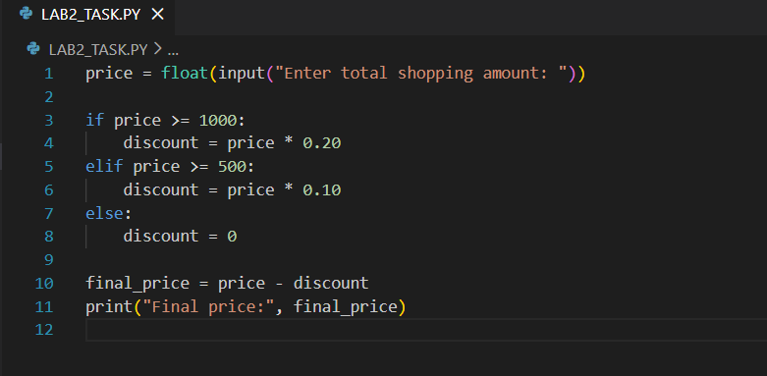
Output:

7. Write a program to Ask for temperature, humidity, and wind speed and classify the
weather:
➢ Pleasant
➢ Normal
➢ Harsh
Code:

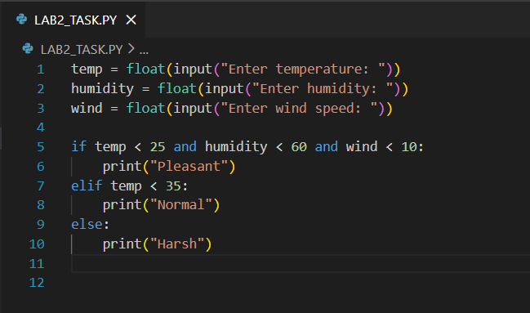
Output:
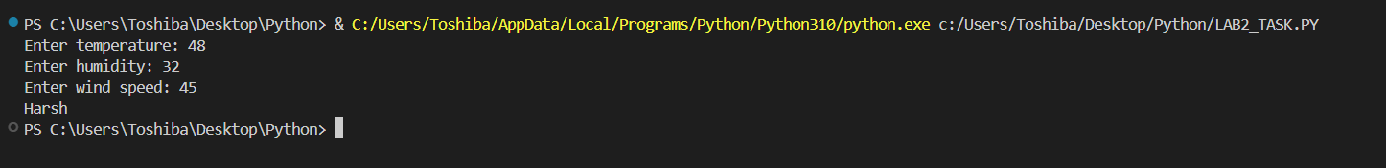

8. Write a function that takes a price and tax percentage and returns the final price after
tax.
Code:
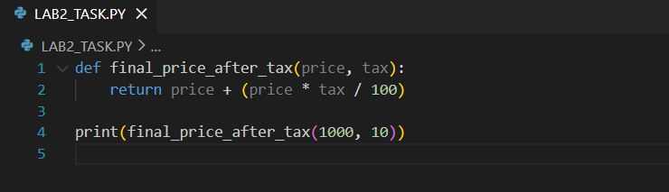
Output:
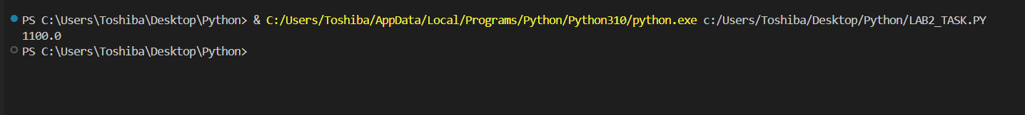

9. Make a function that accepts a number and returns its factorial.
Code:
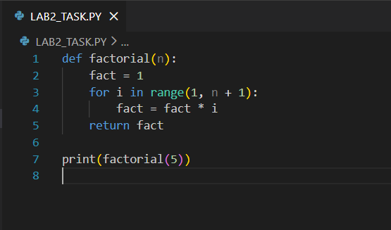
Output:
10. Write a function that takes a list of numbers and returns the average.
Code:
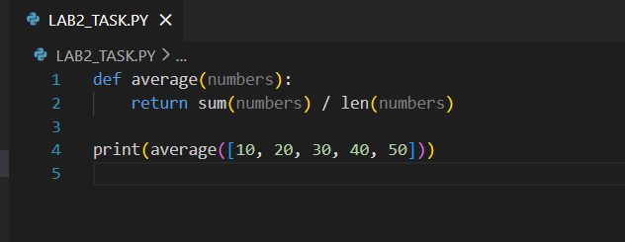
Output:
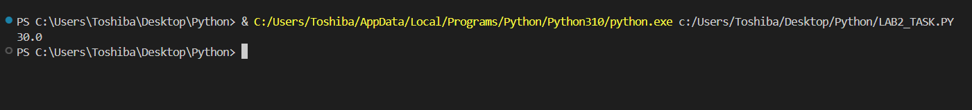

11. Write a function that accepts a temperature in Celsius and returns:
"Cold" if temp < 10
"Warm" if 10–25
"Hot" if > 25
Code:
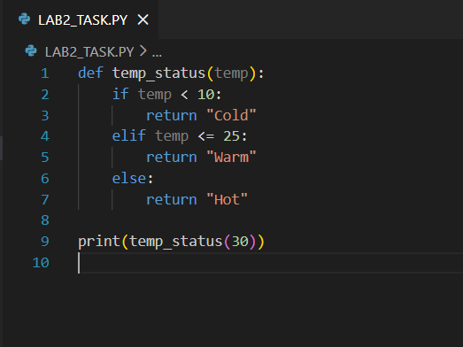
Output:
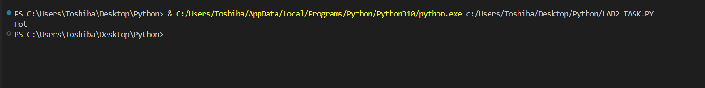

12. Create a function that takes two numbers and returns:
The sum
The difference
The product
Code:
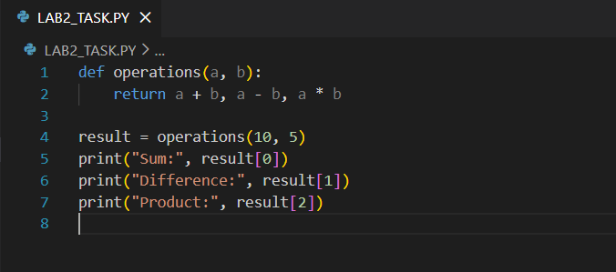
Output:
